**Inverse Trigonometric Functions**

In order to use inverse trigonometric functions, we need to understand that an inverse trigonometric function “undoes” what the original trigonometric function “does,” as is the case with any other function and its inverse. In other words, the domain of the inverse function is the range of the original function, and vice versa, as summarized below.

|  |  |  |
| --- | --- | --- |
|  | Trigonometric Function, $f$ | Inverse Trigonometric Function, $f^{-1}$ |
| Domain | Angle Measure | Right Triangle Ratio |
| Range | Right Triangle Ratio | Angle Measure |

However, we should now understand that none of the six trigonometric functions are one-to-one (they all fail the horizontal line test) and thus we will need to restrict the domain of each trigonometric function to yield a new function that is one-to-one, and thus invertible.

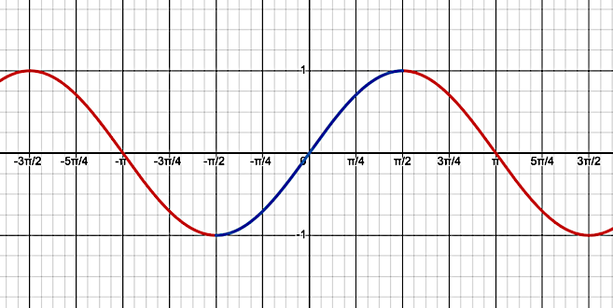

$f\left(θ\right)=\sin\left(θ\right)$

Domain Restriction: $-\frac{π}{2}≤θ≤\frac{π}{2}$

Range: $[-1,1]$

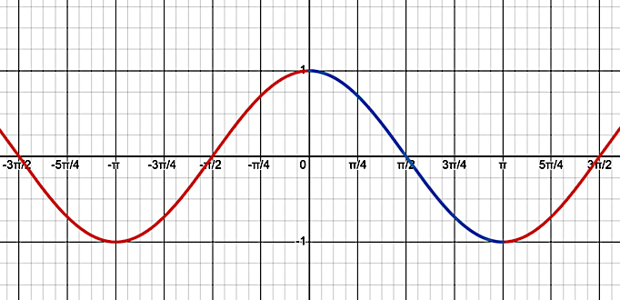

$$g\left(θ\right)=cos⁡(θ)$$

Domain Restriction: $0≤θ≤π$

Range: $[-1,1]$

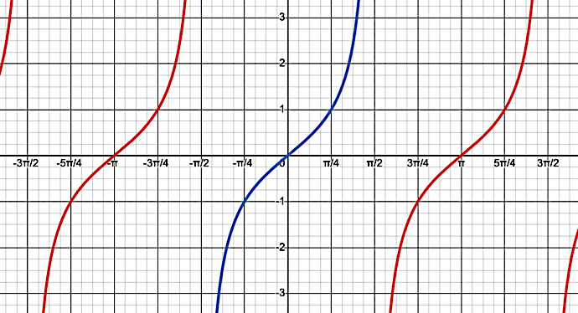

$h\left(θ\right)=tan⁡(θ)$

Domain Restriction: $-\frac{π}{2}<θ<\frac{π}{2}$

Range: $\left(-∞,∞\right)$

NOTE: Range is NOT impacted even though we restricted the domain for each function above.

Example 1: Determine the exact value for each of the following expressions.

$\sin^{-1}\left(\frac{1}{2}\right)$ $\cos^{-1}\left(\frac{\sqrt{3}}{2}\right)$ $\tan^{-1}{(1})$

**Notation**

Below is a summary of another common way to notate inverse trigonometric functions.

$\arcsin\left(\frac{y}{r}\right)=\sin^{-1}\left(\frac{y}{r}\right)=θ$ $\operatorname{arccsc}\left(\frac{r}{y}\right)=\csc^{-1}\left(\frac{r}{y}\right)=θ$

$\arccos\left(\frac{x}{r}\right)=\cos^{-1}\left(\frac{x}{r}\right)=θ$ $\operatorname{arcsec}\left(\frac{r}{x}\right)=\sec^{-1}\left(\frac{r}{x}\right)=θ$

$\arctan\left(\frac{y}{x}\right)=\tan^{-1}\left(\frac{y}{x}\right)=θ$ $\operatorname{arccot}\left(\frac{x}{y}\right)=\cot^{-1}\left(\frac{x}{y}\right)=θ$

Example 2: Determine the exact value for each of the following expressions.

$\operatorname{arcsec}{(\sqrt{2}})$ $\operatorname{arccot}\left(\frac{\sqrt{3}}{3}\right)$ $arcsin⁡(0)$

$\arccos\left(-\frac{1}{2}\right)$ $arccsc⁡(-2)$ $arctan⁡(-\sqrt{3})$

**Compositions**

The most important thing to keep in mind when working with inverse trigonometric functions, is that none of them existed until we restricted the domain of the trigonometric functions. Thus, all inverse trigonometric functions have restricted ranges. In other words, inverse trigonometric functions can only give us angle measure in the restricted ranges.

|  |  |  |  |
| --- | --- | --- | --- |
| Function | Domain | Range | Visual |
| $$\arcsin\left(\frac{y}{r}\right)=θ$$ | $$-1≤\frac{y}{r}≤1$$ | $$-\frac{π}{2}≤θ≤\frac{π}{2}$$ |  |
| $$\arccos\left(\frac{x}{r}\right)=θ$$ | $$-1≤\frac{x}{r}≤1$$ | $$0≤θ≤π$$ |  |
| $$\arctan\left(\frac{y}{x}\right)=θ$$ | $$-∞<\frac{y}{x}<∞$$ | $$-\frac{π}{2}<θ<\frac{π}{2}$$ |  |

Example 3: Determine the exact value for each of the following expressions.

$\arcsin\left(\sin\left(\frac{π}{3}\right)\right)$ $\arccos\left(\cos\left(\frac{5π}{6}\right)\right)$ $\arctan\left(\tan\left(-\frac{π}{4}\right)\right)$

$\arccos\left(\cos\left(\frac{5π}{3}\right)\right)$ $\arctan{(\tan\left(\frac{5π}{4}\right)})$ $\arcsin\left(\sin\left(\frac{7π}{6}\right)\right)$

Example 4: Determine the exact value for each of the following expressions.

$\sin\left(\arccos\left(-\frac{\sqrt{3}}{2}\right)\right)$ $\cos\left(\arctan\left(-2\right)\right)$

$\sec\left(\arcsin\left(-\frac{1}{3}\right)\right)$ $\csc\left(\operatorname{arccot}\left(\frac{\sqrt{7}}{3}\right)\right)$

**Pythagorean Identities**

Recall that for any angle in standard position and the corresponding right triangle created by dropping a perpendicular from the terminal side to the $x$–axis, we have

$$x^{2}+y^{2}=r^{2}$$

Example 5: Manipulate the above equality by dividing both sides by the quantity $r^{2}$, then use the definitions of sine and cosine to rewrite the result.

Now manipulate the equality by dividing both sides by $\left(i\right)\sin^{2}{(θ)} \left(ii\right)\cos^{2}{(θ)}$

**Basic Trigonometric Equations**

Solving trigonometric equations is similar to solving linear and quadratic equations. The difference is we need to isolate the function first, then use the properties of inverse trigonometric functions to determine the reference angle. From there we can identify all angles in the solution set, which are typically requested on the interval $0≤θ<2π$.

For example: $2\cos\left(θ\right)-3=-5$ $2\sin^{2}{(θ)}-1=0$

$2\cos\left(θ\right)=-2$ $2\sin^{2}{(θ)}=1$

$\cos\left(θ\right)=-1$ $\sin^{2}{(θ)}=\frac{1}{2}$

$θ=π$ $\sin\left(θ\right)=±\frac{\sqrt{2}}{2}$

$θ=\frac{π}{4},\frac{3π}{4},\frac{5π}{4}.\frac{7π}{4}$

Example 6: Solve the following trigonometric equation on the interval $0≤θ<2π$

$3\tan{(θ)}-\sqrt{3}=0$ $\left(2\cos\left(θ\right)-1\right)∙\left(\sin\left(θ\right)\right)=0$

$\left(\csc\left(θ\right)+\sqrt{2}\right)∙\left(\cot\left(θ\right)-1\right)=0$ $4\cos^{2}{(θ)}-1=0$